**Middle East Technical University**

**Department of Chemical Engineering**

**CHE305 Thermodynamics II**

**CHE305**

**(Due Date:** 14.06.2023**)**

**Submitted to:** Prof. Dr Naime Aslı Sezgin

**Submitted by *Group 9***

BEREKETOĞLU, Abdullah Burkan

SARI, Naciye

İLMAN, Mert

*METU, Ankara, 2023*

***Problem Statement***

Consider an ideal mixture containing 20% methane (1) and 45% ethane (2) and n-butane (3) at 373 K and 15 bar. Determine the fugacities of methane, ethane, and n-butane in the mix using the Perg-Robinson equation of state.

***Approach***

***Solution Algorithm***

% Given critical properties

% Methane (CH4)

Tc1 = 190.6; % Critical temperature (K)

Pc1 = 45.99; % Critical pressure (bar)

% Ethane (C2H6)

Tc2 = 305.3; % Critical temperature (K)

Pc2 = 48.72; % Critical pressure (bar)

% n-Butane (C4H10)

Tc3 = 425.2; % Critical temperature (K)

Pc3 = 37.96; % Critical pressure (bar)

%Tc and Pcs are from dortmund database

% Given composition (in mole fraction)

z = [0.2; 0.45; 0.35];

% Universal gas constant (bar L / mol K)

R = 0.08314;

% Define temperature and pressure ranges for analysis

temperature_range = [323, 373, 423]; % in K

pressure_range = [15, 20, 25]; % in bar

% Preallocate arrays for fugacity values

fugacity_ethane = zeros(numel(temperature_range), numel(pressure_range));

fugacity_methane = zeros(numel(temperature_range), numel(pressure_range));

fugacity_nbutane = zeros(numel(temperature_range), numel(pressure_range));

% Perform calculations for different temperature and pressure values

for i = 1:numel(temperature_range)

for j = 1:numel(pressure_range)

T = temperature_range(i);

P = pressure_range(j);

% Peng-Robinson constants for the components

% Methane (CH4)

a1 = 0.45724 * (R * Tc1)^2 / Pc1;

b1 = 0.07780 * (R * Tc1) / Pc1;

% Ethane (C2H6)

a2 = 0.45724 * (R * Tc2)^2 / Pc2;

b2 = 0.07780 * (R * Tc2) / Pc2;

% n-Butane (C4H10)

a3 = 0.45724 * (R * Tc3)^2 / Pc3;

b3 = 0.07780 * (R * Tc3) / Pc3;

% Mixing rule for the Peng-Robinson parameters

amix = z(1) * sqrt(a1 * a1) + z(2) * sqrt(a2 * a2) + z(3) * sqrt(a3 * a3);

bmix = z(1) * b1 + z(2) * b2 + z(3) * b3;

% Calculate fugacity coefficients

A = amix * P / (R * R * T * T);

B = bmix * P / (R * T);

coeffs = [1, -1, A - B - B^2, -A * B];

Z = roots(coeffs);

% Select the correct root (Z>1) and calculate fugacity coefficients

Z = Z(Z > B);

fugacity_coeff = Z - 1 - log(Z - B);

% Calculate fugacities

fugacity = fugacity_coeff * P;

% Extract fugacities

fugacity_ethane(i, j) = real(fugacity(1));

fugacity_methane(i, j) = real(fugacity(2));

fugacity_nbutane(i, j) = real(fugacity(3));

% Print fugacities

fprintf('Temperature: %d K, Pressure: %d bar\n', T, P);

fprintf('Fugacity of Ethane: %.4f bar\n', fugacity_ethane(i, j));

fprintf('Fugacity of Methane: %.4f bar\n', fugacity_methane(i, j));

fprintf('Fugacity of n-Butane: %.4f bar\n', fugacity_nbutane(i, j));

fprintf('\n');

end

end

% Plotting fugacity vs. temperature

figure;

hold on;

for i = 1:numel(pressure_range)

plot(temperature_range, fugacity_ethane(:, i), '-o', 'DisplayName', sprintf('Ethane (P = %d bar)', pressure_range(i)));

plot(temperature_range, fugacity_methane(:, i), '-o', 'DisplayName', sprintf('Methane (P = %d bar)', pressure_range(i)));

plot(temperature_range, fugacity_nbutane(:, i), '-o', 'DisplayName', sprintf('n-Butane (P = %d bar)', pressure_range(i)));

end

hold off;

xlabel('Temperature (K)');

ylabel('Fugacity (bar)');

legend('Location', 'northeast', 'FontSize', 8);

title('Fugacity vs. Temperature');

% Plotting fugacity vs. pressure

figure;

hold on;

for i = 1:numel(temperature_range)

plot(pressure_range, fugacity_ethane(i, :), '-o', 'DisplayName', sprintf('Ethane (T = %d K)', temperature_range(i)));

plot(pressure_range, fugacity_methane(i, :), '-o', 'DisplayName', sprintf('Methane (T = %d K)', temperature_range(i)));

plot(pressure_range, fugacity_nbutane(i, :), '-o', 'DisplayName', sprintf('n-Butane (T = %d K)', temperature_range(i)));

end

hold off;

xlabel('Pressure (bar)');

ylabel('Fugacity (bar)');

legend('Location', 'northeast', 'FontSize', 8);

title('Fugacity vs. Pressure');

***Results and Discussion***

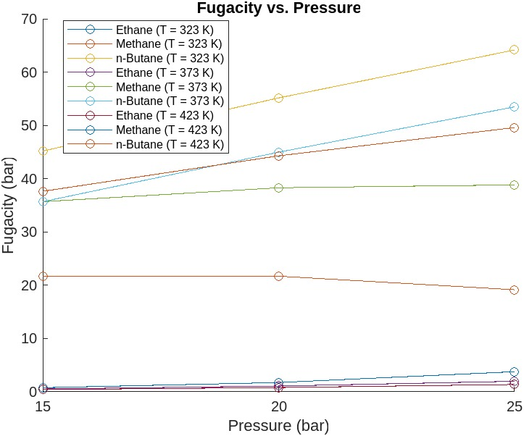

Figure 1. *Fugacity vs. Pressure*

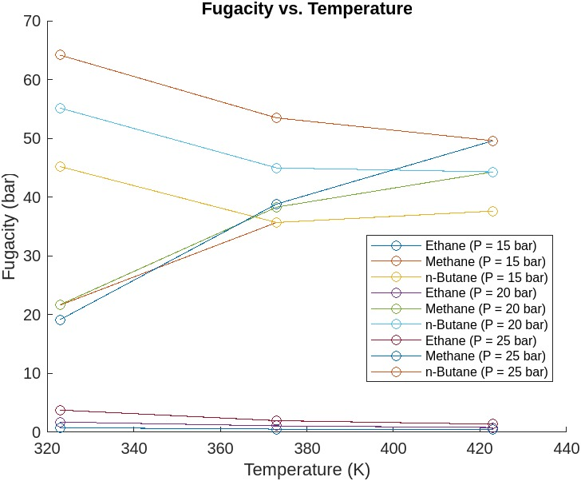

Figure 2. *Fugacity vs. Temperature*

The generated plots offer valuable insights into the behaviour of fugacity for a mixture of methane, ethane, and n-butane under varying temperature and pressure conditions. The Fugacity vs. Pressure plot illustrates that increasing pressure generally leads to higher fugacity values for all components at each temperature. This is attributed to elevated pressure-enhancing molecular interactions, resulting in increased fugacity. Ethane and n-butane exhibit a more pronounced response to pressure changes compared to methane, owing to their higher critical pressures. Similarly, the Fugacity vs. Temperature plot demonstrates that as temperature increases, the fugacity of all three components generally decreases. This behaviour is expected as higher temperatures tend to weaken the attractive forces between gas molecules, leading to lower fugacity values. Ethane and n-butane are more sensitive to temperature variations compared to methane due to their higher critical temperatures.